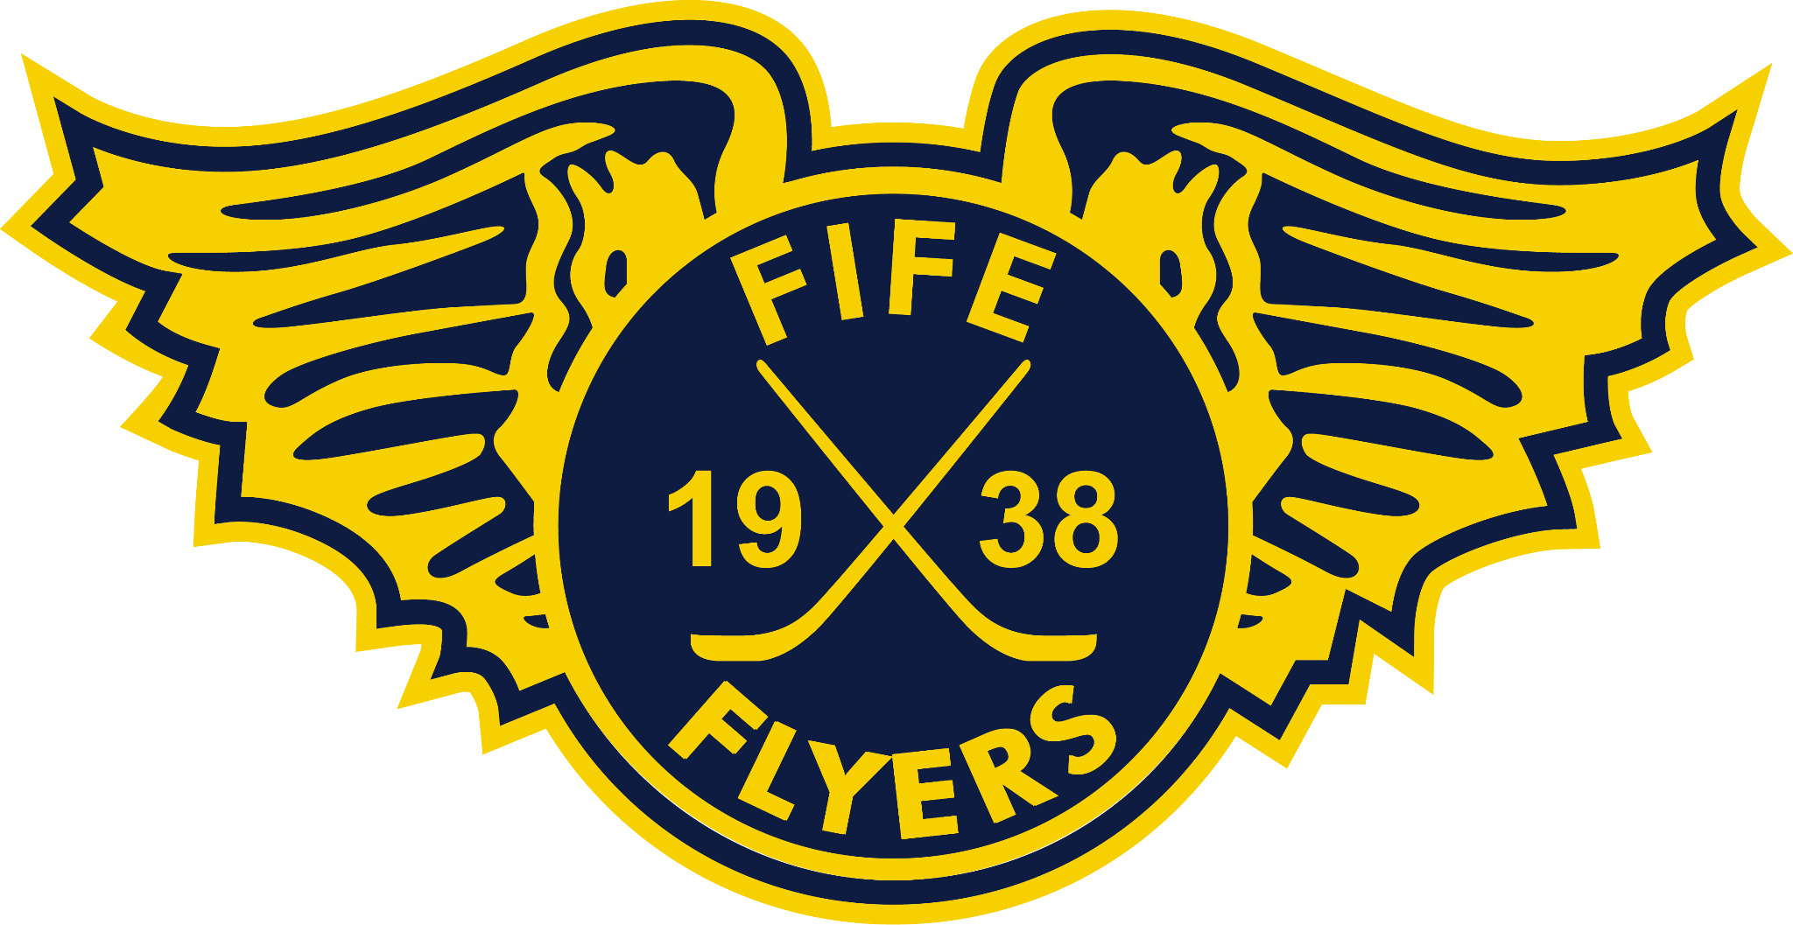
FIFE FLYERS ‘KIDS TAKEOVER NIGHT’ – APPLICATION & CONSENT FORM
EVENT DATE: 10 January 2026 vs. Sheffield Steelers
LOCATION: Fife Ice Arena, Rosslyn St, Kirkcaldy KY1 3HS
Child’s details:
Name:
Age of child:

Preferred Roles:
(please mark the child’s preferences in order, with 1 being top, 11 being the lowest preference). Spaces are limited, so it is not guaranteed that children who are successful will be allocated their first choice position)
If there is a position your child wouldn’t be confident taking part in, please leave the corresponding slot empty.
Junior coach
Mini Geordie Munro
Assistant announcer
Junior photographer
Post game interviewer
Livestream interview guest
Puck drop presenter
Man of the match presenter
Merchandise Assistant (shop)
Face Painting assistant
Shirt off the back + Chuck-a-puck seller Assistants

Parent or Carer’s details:
Name:
Address:
Telephone number:

Emergency contact details (if different from above):
Name:
Telephone number:

Any extra help we need to provide (for example due to a disability):

Do we need to know about any medical conditions or allergies?

Important Information for parents and carers
The Fife Flyers aim to provide a safe and enjoyable experience for every child participating in Saturday’s kids takeover night.
To help us achieve this, please note the following information:
- All questions on the consent form must be completed and signed by the parent or carer before any child can be considered for a role.
- You and your child must already have tickets for the game, or be current season ticket holders, to participate
- You must be able to arrive at Fife Ice Arena by 4.45pm to allow children to be paired up with their buddies
- Parents and carers should ensure children carry any necessary medication (if appropriate) during the duration of the activity.
- Parents and carers understand that children taking part may be separated from them for part of the evening – eg while they are carrying our allocated roles, however for most of the evening, the parent /carer will be responsible for the child and have them in their care
I agree to the following:
My child to participate in the stated activities
Fife Flyers keeping a record of this information for health and safety purposes
My child being filmed or photographed during this activity knowing that the photographs or filming may be used for media purposes
Any medical treatment that my child may need to be given in an emergency
I understand that my child needs to follow the behaviour code and any safety rules set out by the Fife Flyers to keep them and other children safe during the event.
Print name:

Signature: (if filling in form electronically, please type your signature)

Date:

ALL APPLICANTS WILL BE CONTACTED BY END OF DAY FRIDAY 9TH JANUARY TO LET THEM KNOW IF THEY HAVE BEEN SELECTED FOR ONE OF THE ROLES.

